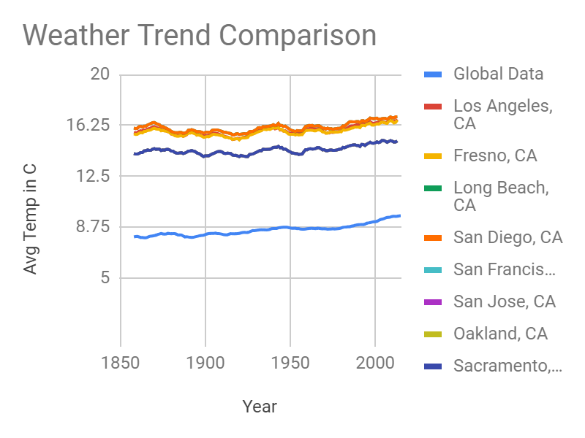

SQL was used to grab the data being presented in the chart.

SELECT city FROM city_list

WHERE country = 'United States';

#Used to view a list of cities in the US.

SELECT * FROM city_data

WHERE city IN ('Los Angeles', 'Fresno', 'Long Beach',

'Oakland', 'Sacramento', 'San Diego',

'San Francisco', 'San Jose')

AND country = 'United States';

#Grabbed cities located in California.

SELECT * FROM global_data;

#Grabbed global data for comparison

Used Google Sheets to chart and compare the data in a line table

The moving average was calculated using a 10-year interval, based on the amount of years given in the data set, I figured this would provide a smoother line to compare data.

To calculate the moving average, I placed the Average formula in cell C12, and input cells B3 to B12 into the formula. I then dragged the formula from C12 down to the remaining cells in column C. I repeated this process for all other "10 - Year MA" columns.

I wanted to compare California city weather trends to that of the global average.

Observations:

1. The cities of California seem to run hotter on average than the overall global average

2. The higher temperatures in California vs Global average may be associated with California having a desert climate.

3. Both the global average and the California average are steadily increasing in temperature. This may be attributed to global warming.

4. Northern California cities seem to be lower on average in temperature than Southern California